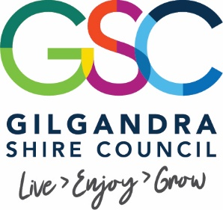
Media Release 17 June 2019

Gilgandra Shire businesses help to create a positive experience for locals and visitors

A number of Gilgandra business have embraced a concept on born a few weeks ago to create a winter wonderland in Gilgandra Shire this July. From what started as an idea to have a bit of fun and decorate a few businesses has now grown to an event that will feature state of the art lighting displays, majority of Miller Street businesses (and many other locations) decorated in winter themes for the month of July and an exciting event to launch the whole thing, not a bad effort for something that did not exist three weeks ago.

The Winter Wonderland project will get underway with a launch event on Friday 5 July starting from 5pm. Economic Development Manager, Randall Medd said the night will have a festival atmosphere and its planned to be a fun few hours.

“As it’s the last day of the school term we are hoping people stick around in Gilgandra and join in the fun. All the participating businesses will turn on their lights and unveil their displays, we are encouraging food businesses to b open as well as other local food options, there will be a winter themed dress up competition for kids and some businesses have indicated they will do their own in-store events.

Randall added the biggest feature will be a lighting display on several local shop facades

“ 32 Hundred Lighting who are a technical partner of Vivid in Sydney, are going to light up a number of buildings in winter themes. This should be spectacular and is only possible through the generous support of 32 Hundred Lighting, Gilgandra and District Community Bank Branch and another corporate supporter who can be publicly named shortly.”

The lighting display will run for three weeks and is sure to attract people to have look at night.

The Gilgandra and District Community Bank Branch will also sponsor a window decorating completion, where the public can vote for their favourite decorated business.

Randall concluded by thanking the businesses for their enthusiasm and encouraged the community to stay turned and get involved

“ The event was created by a group of enthusiastic local businesses and so far the positive response has been fantastic. If there is anyone that would like to run an activity or event they are welcome to contact me. This event has popped up out of nothing so we are still working out details on a daily basis but we will update the community as we can through the Gilgandra Weekly and Councils Facebook page. The most important thing is Friday 5 July from 5pm in Miller Street, that the major event and we have to see plenty of people

Contact
Economic Development Manager
Randall Medd
Ph 68178800

Media Contact
Community Engagement Officer
Susan Brisbane
Ph 68178800

